**ME 8710: Final Exam**

**12th December 2020**

**Ishan Sharma**

**Graduate Student, Department of Mechanical Engineering**

**Introduction to Problem**

Under the given problem for the mentioned constraints, an optimal solution is inbound for low-Earth orbit Applications' desired operating conditions (Altitude < 2000Km). The problem is a typical orbital rocket configuration plan for the given altitude.

The configuration designed for the given application and constraints needs to be tested onto the simulation developed in C++. The methodology adopted to lead a solution for an optimal condition has been defined by the various headers file equations.

In the direction to lead an optimal solution, different approaches have been utilized. Some of the strategies that failed while finding the solution have also been mentioned in the report's further sections, with the potential cause of their failure. The next section of the report highlights the operational constraints given for the above configuration problem.

**Problem Definition**

The problem has defined four operational constraints to estimate the viability and optimality of the rocket launch system. Wherein the operating conditions of the following system are:

**A. Payload Capacity Constraint:**

The design should be such that it can carry a payload of at least 1000kg and less than 15000kg. The payload mass is a significant constraint when defining a given space program's overall efficiency and objectivity.

In usual space programs, the payload could be a satellite, space probe, or spacecraft carrying cargo, humans, etc. The payload is the total mass exclusive of the wet mass and the rocket's dry mass component.

**Wet Mass:**

The rocket's wet mass can be defined as the total initial mass of the rocket that includes the mass of the propellent.

**Dry Mass:**

The rocket's dry mass can be defined as the mass of the rocket at its full ascent.

The payload needs to be defined for the given range, and the rocket configuration should be able to place the payloads into an orbit at least 400 km in altitude.

**B. Dynamic Pressure Constraint:**

The maximum dynamic pressure in which the entire configuration should operate has to be less than 33% of the Atmospheric Pressure, i.e., 33,400 Pa. The maximum dynamic pressure condition defines the point of Max Q.

Max Q is a phenomenon wherein at a point where dynamic pressure change due to increasing the velocity is more significant than due to decreasing air density i.e.

Change in Dynamic Pressure (Increasing Velocity) > Change in Dynamic Pressure (Decreasing Air Density)

This Max Q phenomenon opposes the kinetic energy of the given system. On the contrary, the opposite holds when the system passes over the point of Max Q. Many configurations for this very reason are throttled down near the Max Q periphery to avoid opposition to the system's overall Kinetic Energy.

The ideal throttle-down process should hit the Max Q, and the following considerations have been duly considered to define an optimal configuration for this problem.

**C. Maximum Acceleration Constraint:**

The overall acceleration profile has been limited to 8g, where g is the gravitational acceleration (g =9.8054 m/s2 as defined in the *constants.h*). The g-force component is due to gravitational pull, the gravitational acceleration, i.e., g changes with altitude change and remains constant on the earth's surface.

Figure 1: STES 121 acceleration profile

Typically, A STES 121 ascent profile observed in the above figure is experiencing a maximum of 30m/s2 of acceleration from the lift-off stage to the engine's cut-off stage.

**D. Orbital Acceleration Balance Constraint:**

The orbital acceleration balance is a very significant factor that determines the rocket's ability to enter a stable orbit.

As we know, the thrust generated is to overcome the weight of the rocket. The orbital acceleration is the difference between the centripetal acceleration and acceleration due to gravity.

Orbital Acceleration Balance = Centripetal Acceleration - Acceleration due to gravity (h)

$$OAB= \frac{v^{2}}{r_{Overal}}-g(t)$$

where,

rOverall = Radius of Earth + Final Altitude at a given time instant + Initial Altitude

Acceleration due to gravity is a function of altitude/height(h). It decreases with an increase in altitude.

Ideally, the OAB should be equal to zero. The configuration has been specifically deduced to attain a value in positive domain to maintain and attain a stable orbit with minimum energy requirement.

In this problem, the current formulation does not account for the tangential acceleration component. It does not account for the pitch-over, and only it has the radial component of the acceleration. The orbital acceleration balance profile, if positive, indicates the rocket will attain and maintain a stable orbit.

**Variables in the Problem**

The variables in the given configuration problem, which are user-defined, are:

* Number of Stages
* Type & Number of Booster required (If any)
* Type & Number of First (Main) Stage Engines
* Type & Number of Second Stage Engines (Engines for the second stage are used for the successive stages after the main stage)
* Throttle Profile for Main Stage and Boosters
* Burn Time for different stages in the configuration
* Main Core Diameter
* Payload Carrying Capacity (1000 kg < Payload < 15000 kg)

**Problem Objective**

To work with maximum possible payload configuration and equipping highest efficient rocket engine profiles.

**Ideal Approach for Problem Formulation**

The ideal formulation of the problem would begin with deciding the desired altitude for the given program and the total time of flight, which will work as a constraint to choose from the array of options of choosing from rockets providing different thrust. The ideal formulation has been adopted from Pathways to Exploration as quoted in reference section [1].

In each program, selecting a rocket engine over another, highly depends on the propellent budget, as you have to account for the energy requirements to pull the additional propellant mass as per the program's desired flight time.

**Ideal rocket equation/Tsiolkovsky rocket equation:**

$$∆v= v_{e}\ln{\frac{m_{o}}{m_{f}}= I_{sp}*g_{o}*\ln{\frac{m_{o}}{m_{f}}}}$$

This relation analogy can be observed consistent with the ideal rocket equation, using a mass fraction (mo / mf).

As mentioned in the further section about Hohmann Transfers, they are used to deduce efficient path planning solution for a given source and destination.

**Hohmann** **Transfers**

Figure 2: Hohmann Transfer Representation

$$∆v=\sqrt{\frac{G*M}{R} }* \sqrt{\frac{2R'}{R+R'}-1}$$

$$∆v'=\sqrt{\frac{G*M}{R} }*(1- \sqrt{\frac{2R^{}}{R+R^{'}}})$$

In Hohmann transfer orbit, an elliptical orbit is used to lead transfer between two orbits even with different radii around a standard central body frame. The Hohmann transfer's need emerges from the need to deduce a practical path for the flight duration. Hohmann transfer helps to use the lowest possible amount of propellent to travel between the source and the desired destination.

The above approach encompassing drag, air resistance, and minimum increase in elevation are some of the non-ideal factors, enabling to effectively lay the bounds of the problem and a fecund mathematical model to carry out the optimization for the desired constraints.

Though the above modeling approach is ideal, it does not work for the current scenario, as the problem formulation of this kind needs a lot of instantaneous & comprehensive data profiles for different constraints.

**Failed Approach**

The initial approach utilized the ideal rocket equation to work through the equations and formulate the problem as per the defined problem definition.

$$∆v= v_{e}\ln{\frac{m_{o}}{m_{f}}= I_{sp}*g_{o}*\ln{\frac{m_{o}}{m_{f}}}}$$

Where,

$$∆v:delta(v)- the maximum change in velocity$$

$$m_{o}=Initial Total Mass$$

$$I_{sp}=Specific Impulse$$

$$v_{e}=Exhaust Velocity$$

$$g_{o}=Acceleration due to gravity (at t= 0)$$

Now, It can be also be written in the form of

$$m_{o }= {(e}^{\frac{∆v}{I_{sp}*g_{o}}})(m_{p}+m_{d})$$

Where,

$$m_{p}=Mass of Payload (in Kg)$$

$$m_{d}=Dry Mass of the Rocket$$

The above mass model can be further modeled for the change in mass as defined below, wherein the q(t) i.e the flow rate of expelled gas is equivalent to change in mass for the given system.

$$\frac{dm}{dt}= -q(t)$$

$$F_{Applied to the Rocket by Exhaust}= F_{Applied to the Exhaust by Rocket}$$

If rocket experiences gravity, the total force on the rocket is equivalent to –

$$F_{rocket}\left(t\right)= F_{Applied to Exhaust by Rocket}\left(t\right)+gm(t)$$

Where, g = gravitational acceleration (m/s2)

The force on the exhaust is its flow rate multiplied by the velocity component

$$F_{Applied on Exhaust by Rocket}\left(t\right)= q\left(t\right)*v(t)$$

Let, w be the velocity of the exhaust relative to the rocket

$$F_{Rocket}\left(t\right)= q\left(t\right)\left[w+ v\left(t\right)\right]+m\left(t\right)*g$$

In this case, F= ma idealization would deem wrong, as mass(m) changes with respect to time. Again, this approach was deemed wrong if mass taken constant due to fixed mass idealization. With insufficient data profiles could not deduce instantaneous mass calculations. Though, even above equations needed more comprehensive data profiles to lead the calculations further.

Even the further instantaneous mass calculations were not coherent with that of the provided simulation suite, so this approach was also dropped. Further, an ideal solution could begin with Euler Equation formulation of the above problem, even that led to inaccurate calculations. A system in place of the above, if had modelled the changed in momentum then the formulation might be correct for the instantaneous component rather than the

F = mass * acceleration

Furthermore, the many researchers [2] recommends utilization of Heun’s Rule for more accurate approximation and calculations.

**Objective Formulation Pedagogy**

After an unsuccessful formulation, in this final formulation section, the problem has been formulated to deduce feasible configurations for the highest payload for the user-defined altitude. The user-defined altitude will set the upper bound over the altitude profile of the given problem.

* **Designed Payload Capacity = 15,000 kg (Agile & Equivalence Constraint)**
* **Desired Altitude >= 1000 km (Agile Constraint)**
* **Minimum Altitude Constraint = 400 km (Given Constraint)**

Primarily, the velocity criterion has been calculated to establish the minimum velocity required by the rocket engine profiles to satisfy the given problem's operational constraints and requirements.

Now, from the equations of motion, we can equate the orbital acceleration balance equation as mentioned earlier in the section to zero, we get –

$$\frac{m*v^{2}}{R_{Equivalent}}>= \frac{G*M*m}{{R_{Equivalent}}^{2}}$$

${R^{max}}_{Equivalent}= R_{Earth}+Desired Altitude=\left(6378+1000\right)* {10}^{3}m=$ 7378 km

${R^{min}}_{Equivalent}= R_{Earth}+Minimum Altitude=\left(6378+400\right)* {10}^{3}$ m = 6778 km

Equivalent equation for velocity can be written as

$$v≥ \sqrt{\frac{G*M}{R_{Equivalent}}}$$

Case – 1 (With ${R_{Equivalent}}^{Max}$)

$$v_{min}>=7619 m/s$$

The vmin puts a constraint over the minimum velocity required to achieve the corresponding desired altitude.

After defining the velocity criterion, the burn time for the entire configuration duration has been calculated using the 8g constraint of acceleration.

* **Acceleration <= 8g (Given Constraint)**
* Allowable Acceleration permitted as per the laid constraint: (2g 7.5g)

The burn time expression can be written as –

$$t_{Burn Time}= \sqrt{\frac{2*(Desired Altitude)}{g-force (permissible)}}$$

$${t^{at 2g}}_{Burn Time}≤ \sqrt{\frac{2*1000*1000}{2*9.80556}}≤ 319.32 sec$$

Above are the Burn time calculations at different permissible acceleration range. The Burn time to achieve the desired altitude at 2g should be less than 319.32 sec for the total duration, for the rocket to achieve the desired altitude.

Now, after deducing over the velocity profile constraints and burn time constraints for our configuration. We will further use Selection Matrix and Ranking Strategy to choose the best option out of available rocket engines for our first and successive stages, respectively.

**Objective – Rocket Engine Selection - Using Selection Matrix**

A. Selection Criteria

In the first criteria, the all the engines are ranked using (Thrust/Dry Mass Ratio). Further, the engine options with higher rank order are selected and further ranked using second selection criteria i.e. ISP, which defines the overall energy efficiency of a rocket system. As ISP can be used to measure efficiency of rocket to utilize its propellant. Our Selection criteria are as follows

* Selection Criteria I (Thrust / Dry Mass)
* Selection Criteria II (ISP)

Stage 1 (Selection Criteria I)

|  |  |  |  |  |
| --- | --- | --- | --- | --- |
| Stage – I Engine Selection Matrix (Selection Criteria: Thrust/Dry Mass) | | | | |
| Designer | Engine | Stage | Selection Criteria I (Thrust/Dry Mass) | Rank |
| Blue Origin | BE-4 | I | 1714.285714 | 1 |
| SpaceX | Raptor | I | 1621.323529 | 2 |
| NPO | RD-193 | I | 1011.585789 | 3 |

*The above criteria give us the engine option, which are good in providing the necessary thrust and at the same time maintain low weight profile dynamics.*

|  |  |  |  |  |
| --- | --- | --- | --- | --- |
| Stage – I Engine Selection Matrix (Selection Criteria: ISP) | | | | |
| Designer | Engine | Stage | Selection Criteria II (ISP) | Rank |
| Blue Origin | BE-4 | I | 450 | 1 |
| SpaceX | Raptor | I | 330 | 2 |
| NPO | RD-193 | I | 311.2 | 3 |

*Ideal Engine Choice: BE – 4 as per the Ranking of the selection matrix.*

**First Iteration**

*A simulation profile was run with single stage was run, but it did not achieve or satisfied the laid operating constraints. It needed much more thrust to achieve the desired altitude profile. Second stage is needed.*

Now, using the selection criteria II, using the ISP, the stage – I engines are further ranked. ISP is a measure as to how effectively does the rocket utilizes its given propellent mass.

Now, similarly second stage engines are selected using the Selection Criteria I and Selection Criteria II

|  |  |  |  |  |
| --- | --- | --- | --- | --- |
| Stage – II Engine Selection Matrix (Selection Criteria: Thrust/Dry Mass) | | | | |
| Designer | Engine | Stage | Selection Criteria I (Thrust/Dry Mass) | Rank |
| Snecma | Vinci | II | 642.8571429 | 3 |
| SpaceX | Raptor V | II | 1580.882353 | 2 |
| SpaceX | Merlin 1DV | II | 2087.234043 | 1 |

*Similarly, Stage II selection based on Selection Criteria II*

|  |  |  |  |  |
| --- | --- | --- | --- | --- |
| Stage – II Engine Selection Matrix (Selection Criteria: ISP) | | | | |
| Designer | Engine | Stage | Selection Criteria I (Thrust/Dry Mass) | Rank |
| Snecma | Vinci | II | 467 | 1 |
| SpaceX | Raptor V | II | 380 | 2 |
| SpaceX | Merlin 1DV | II | 348 | 3 |

After seeing the Stage – II selection based on the mentioned selection criteria. Now, even with Rank – 1, Space X (Raptor V) is an ideal choice, as it can generate far more thrust than the Snecma Vinci. Though, this would lead to trade-off in terms of the weight but would result into a greater number of engines which would eventually increase the overall mass of the second stage engine system.

*Stage II Engine Selection: Space X (Raptor V)*

**Second Iteration:**

*The desired altitude profile and orbital acceleration positive profile not achieved. Thrust required is more. Possible Iteration to bring in more engines at primary stage with an engine with lower diameter.*

*Possible with Stage – I Engine (Rank – 2): Space X Raptor (Low Diameter compared to BE – 4)*

*Engine Selection (Stage – I): Space X Raptor*

**Third Iteration**

*Orbital Acceleration balance is not positive even with increased number of engines at primary stage. The configuration might need a set of boosters to slightly increase the thrust profile for primary stage. A Booster who has moderate burn time is required.*

|  |  |  |  |  |
| --- | --- | --- | --- | --- |
| Stage – II Engine Selection Matrix (Both Selection Criteria) | | | | |
| Designer | Engine | Stage | (Thrust/Dry Mass) | ISP |
| NorthUp | Gem63 | Booster | 33.73 | 360 |

*The above choice has high ISP and considerably amount of Thrust/Dry Mass Ratio.*

**Fourth Iteration**

Orbital Acceleration balance profile Achieved with all the constraints satisfied.

|  |  |  |  |
| --- | --- | --- | --- |
| Final Configuration after Iteration IV | | | |
| Type | Designer | Engine | Number of Engines |
| Stage – I | SpaceX | Raptor | 5 |
| Stage – II | SpaceX | RaptorV | 1 |
| Booster | NorthUp | Gem63 | 2 |

Total Burn time for the entire flight was 300 seconds less than the maximum burn time as calculated before. The Max Q range for the current configuration lies between 25 – 40 seconds’ range.

**Objective – Main Core Diameter Selection**

Using the Circle in Circle Algorithm, the main core diameter has been calculated using [3] Engineering Toolbox. The main core diameter calculated was 3.87m for the configuration enlisted in fourth iteration.

**Results**

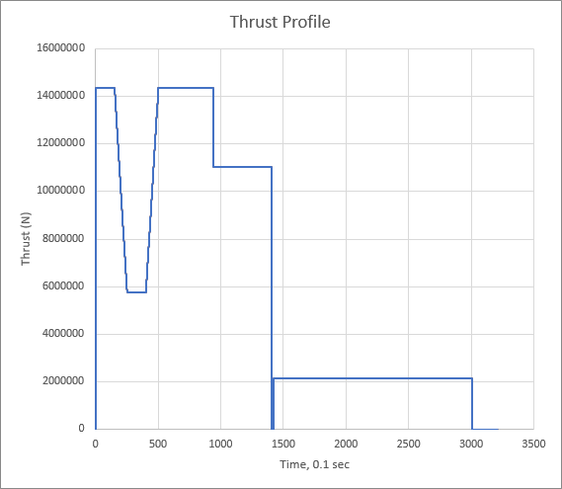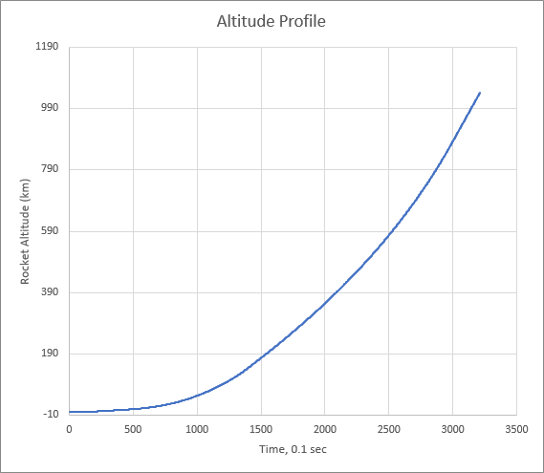

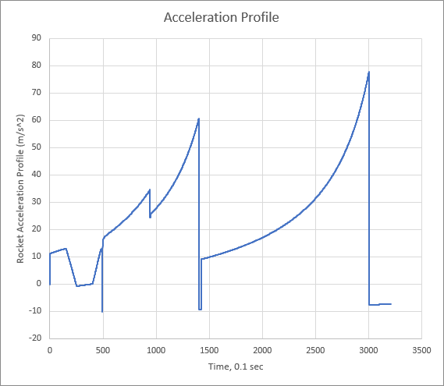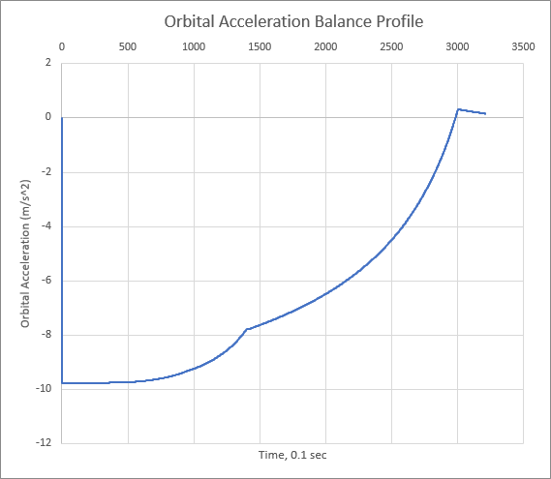

Figure 6: Orbital Acceleration Balance Profile

Figure 4: Altitude Profile

Figure 3: Thrust Profile

Figure 5: Acceleration Profile

The above results are for the thrust profile, altitude profile, acceleration profile, orbital acceleration balance profile and dynamic pressure profile.

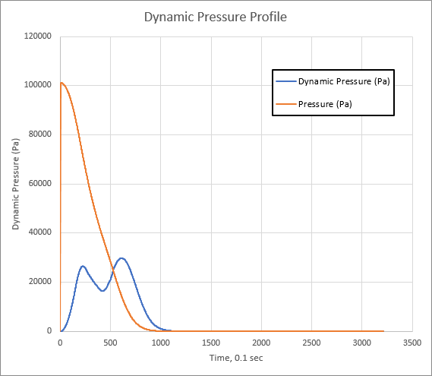

Figure 7: Dynamic Pressure Profile

**Conclusion**

All the involved constraints satisfied as –

* Orbital Acceleration Balance Profile is Positive
* Acceleration is less than 8g
* Dynamic Pressure is less than 33% of the Atmospheric Pressure
* Rocket Configuration should be able to carry a maximum payload of 15000kg (Max Payload)

and hence the above configuration is feasible.

**References**

1. Book: A National Research Council, Pathways to Exploration: Rationales and Approaches for a U.S. Program of Human Space Exploration, 978-0-309-30507-5 (2014)
2. *Euler Equations for Rockets*. (2014, June 12). NASA Web Portal. <https://www.grc.nasa.gov/www/k-12/rocket/eulereqs.html>
3. Engineering ToolBox, (2013). *Smaller Circles within a Larger Circle*. [online] Available at: https://www.engineeringtoolbox.com/smaller-circles-in-larger-circle-d_1849.html [Accessed Day Mo. Year].